Server System Management - Linux

Lab 0 - preparation

INHOUD

1 Installation Linux virtual machine 3

1.1 Preparing the VM 3

1.2 Installing the Operating System 3

1.3 Verification 5

# 

# Installation Linux virtual machine

In this lab you will have to install Debian 12 (bookworm) as a VM in VMware Workstation Pro.

## Preparing the VM

Copy/Download the (first) ISO-file of Debian 12.5 (or a more recent version) to a folder on your laptop.

The name of this ISO-file is **debian-12.5.0-amd64-netinst.iso** and the URL for this file is:

<https://cdimage.debian.org/debian-cd/current/amd64/iso-cd/debian-12.5.0-amd64-netinst.iso>

In VMware Workstation click on the menu item “**Create** **New Virtual Machine**” to create a new virtual machine (VM). The wizard will help you with this.

* + Choose ***Typical installation***
  + Choose ***I will install the operating system later***
  + Enter the name ***Debian-YourFamilyNameWithoutSpaces-YourFirstNameWithoutSpaces-Prime*** as the name for your OS
  + Choose a **hard disk of 20 GB** (default setting) and choose to save the virtual disk **as a single file**.
  + Click on the **Finish** button

## Installing the Operating System

Connect your downloaded ISO file to the CD/DVD of your Debian-VM in VMware Workstation. You can do that via the settings menu of your Debian-VM.

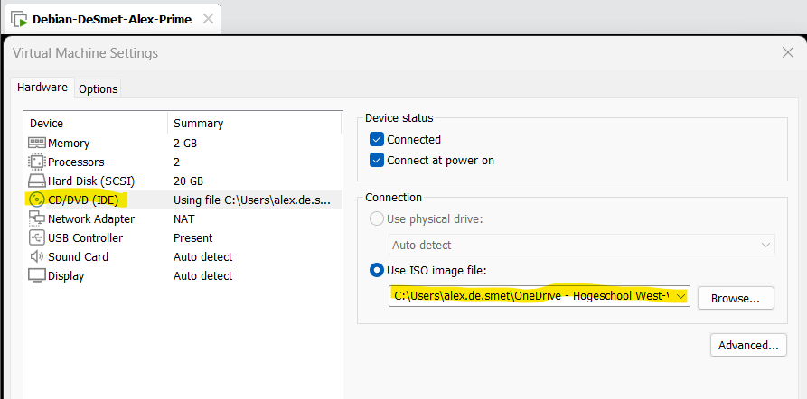

Power on your Debian-VM and follow these instructions:

* Click on the first option (**Install**). Attention: Don’t go for the **graphical install!**

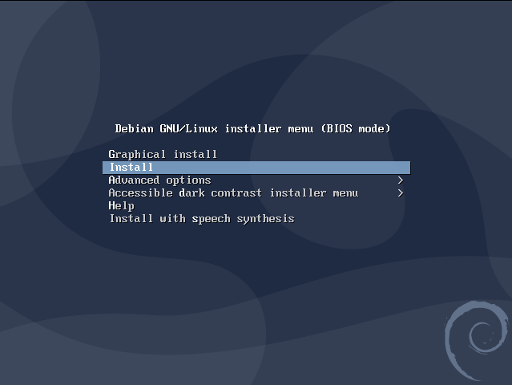

* Choose ***English*** as language.
* Choose ***Belgium*** as country. (other/Europe/Belgium)
* Choose ***United States*** as default locale setting.
* Choose ***Belgian*** as keyboard. (if you have an azerty keyboard, otherwise, choose your own type)
* Choose ***debian-yourfamilynamewithoutspaces-yourfirstnamewithoutspaces-prime*** as hostname.
* Choose ***local*** as domain name.
* Enter a password for the root account. Attention: press NumLock key if you want to use digits !
* Enter ***your family name and your first name*** as full name for the regular user.
* Enter **yourfamilyname*your*firstname** (together, no spaces) as username for your account.
* Enter a ***password for your account***.
* Choose ***Guided-use entire disk*** (default setting) as partitioning method.
* Choose the proposed disk (sda) to partition.
* Choose ***All files in one partition*** as partitioning scheme.
* Choose ***Finish partitioning and write changes to disk***.
* Choose *<****Yes****>* to write the changes to disk.
* Choose *<****No****>* to indicate that you will not scan another CD/DVD should the system ask you for it
* Choose *<****Yes****>* to indicate that you want a network mirror.
* Choose ***Belgium*** as a Debian archive mirror country..
* Choose ***deb.debian.org*** as Debian archive mirror.
* Choose ***Continue*** to indicate that you do not use a http proxy.
* Choose ***<No>*** to indicate that you don’t want to participate in the package usage survey.
* Select ONLY the ***standard system utilities*** and the **SSH server** in the software menu
* **IMPORTANT** !!!! (**unselect** the “**Debian desktop environment**”, **GNOME** by pressing the space bar)

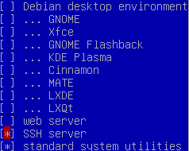

* Choose *<****Yes****>* to install the GRUB boot loader to the master boot record.
* Choose ***/dev/sda*** as device for boot loader installation.
* Choose “***Continue***” to complete the installation.

## Verification

After a while, your new fresh Debian will start up and show you the login prompt.

Log in with your yourfamilynameyourfirstname user on the vmware console and type the following command:

$ date ; ip a s

Upload a SCREENSHOT of the logged in session as proof of your success! (example below)

